**Riešenie 3. zadania**

**SYNTÉZA** **SEKVENČNÝCH LOGICKÝCH OBVODOV**

Úlohy:

1. V pamäťovej časti použite minimálny počet preklápacích obvodov **JK-PO**.
2. Navrhnuté B-funkcie v tvare MDNF overte programom pre ESPRESSO. Pri návrhu B-funkcií klaďte dôraz na skupinovú minimalizáciu funkcií.
3. Optimálne riešenie (treba zhodnotiť, ktoré riešenie je lepšie a prečo) vytvorte obvod s členmi NAND (výhradne NAND, t.j. ani žiadne NOT).
4. Výslednú schému nakreslite v simulátore LogiSim (príp. LOG alebo FitBoard) a overte simuláciou.
5. Riešenie vyhodnoťte (zhodnotenie zadania, postup riešenia, vyjadrenie sa k počtu logických členov).

**Riešenie**

Zadaná postupnosť: **101101**

Prechodová tabuľka pre automat typu Moore

|  |  |  |  |  |
| --- | --- | --- | --- | --- |
|  | Nový stav | | Y | Čo je splnené? |
| stav | x=0 | x=1 |  |
| S0 | S0 | S1 | 0 | Nič |
| S1 | S2 | S1 | 0 | “1” |
| S2 | S0 | S3 | 0 | “10” |
| S3 | S2 | S4 | 0 | “101” |
| S4 | S5 | S1 | 0 | “1011” |
| S5 | S0 | S6 | 0 | “10110” |
| S6 | S2 | S4 | **1** | “101101” |

**Prechodový graf typu Moore:**

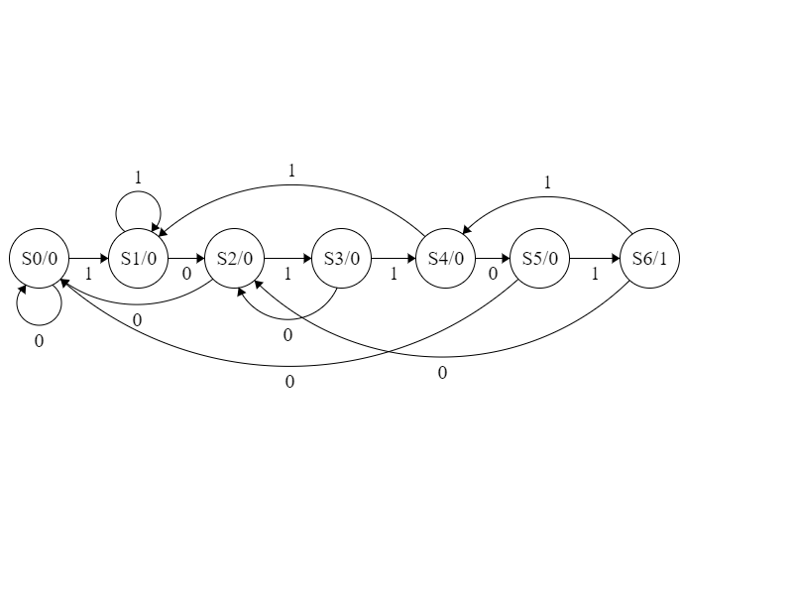

**Kódovanie stavov**

|  |  |  |  |  |  |
| --- | --- | --- | --- | --- | --- |
|  |  |  |  | z3 |  |
|  |  |  | z2 |  |  |
|  |  |  |  |  |  |
|  |  | S0 | S2 | S4 | S1 |
| z1 |  | S3 | X | S6 | S5 |

|  |  |
| --- | --- |
| Stav | z1z2z3 |
| S0 | 000 |
| S1 | 001 |
| S2 | 010 |
| S3 | 100 |
| S4 | 011 |
| S5 | 101 |
| S6 | 111 |

**Prechodová tabuľka pre automat Moore po dosadení zakódovaných stavov**

|  |  |  |  |
| --- | --- | --- | --- |
|  | Nový stav | | výstup |
| stav | x=0 | x=1 | y |
| 000 | 000 | 001 | 0 |
| 001 | 010 | 001 | 0 |
| 010 | 000 | 100 | 0 |
| 100 | 010 | 011 | 0 |
| 011 | 101 | 001 | 0 |
| 101 | 000 | 111 | 0 |
| 111 | 010 | 011 | 1 |

|  |  |  |  |  |  |  |
| --- | --- | --- | --- | --- | --- | --- |
|  |  |  |  |  | z3 |  |
|  |  |  |  | z2 |  |  |
|  |  |  |  |  |  |  |
|  |  |  | 000 | 000 | 101 | 010 |
|  | z1 |  | 010 |  |  |  |
|  |  |  | 011 |  |  |  |
| X |  |  | 001 | 100 | 001 | 001 |
|  |  |  |  |  | D1, D2, D3 |  |



|  |  |  |  |  |  |  |
| --- | --- | --- | --- | --- | --- | --- |
|  |  |  |  |  | z3 |  |
|  |  |  |  | z2 |  |  |
|  |  |  |  |  |  |  |
|  |  |  | 0 | 0 | 0 | 0 |
|  | z1 |  | 0 | X | 0 | 0 |
|  |  |  | 0 | X | 1 | 0 |
| X |  |  | 0 | 0 | 0 | 0 |
|  |  |  |  |  | Y= Z1.Z2.X |  |

|  |  |  |  |  |  |  |
| --- | --- | --- | --- | --- | --- | --- |
|  |  |  |  |  | z3 |  |
|  |  |  |  | z2 |  |  |
|  |  |  |  |  |  |  |
|  |  |  | 0 | 0 | 1 | 0 |
|  | z1 |  | 0 | X | 0 | 0 |
|  |  |  | 0 | X | 0 | 1 |
| X |  |  | 0 | 1 | 0 | 0 |
|  |  |  |  |  | D1 |  |

|  |  |  |  |  |  |  |
| --- | --- | --- | --- | --- | --- | --- |
|  |  |  |  |  | z3 |  |
|  |  |  |  | z2 |  |  |
|  |  |  |  |  |  |  |
|  |  |  | 0 | 0 | 0 | 1 |
|  | z1 |  | 1 | X | 1 | 0 |
|  |  |  | 1 | X | 1 | 1 |
| X |  |  | 0 | 0 | 0 | 0 |
|  |  |  |  |  | D2 |  |

|  |  |  |  |  |  |  |
| --- | --- | --- | --- | --- | --- | --- |
|  |  |  |  |  | z3 |  |
|  |  |  |  | z2 |  |  |
|  |  |  |  |  |  |  |
|  |  |  | 0 | 0 | 1 | 0 |
|  | z1 |  | 0 | X | 0 | 0 |
|  |  |  | 1 | X | 1 | 1 |
| X |  |  | 1 | 0 | 1 | 1 |
|  |  |  |  |  | D3 |  |

**Budiace funkcie pre JK preklápacie obvody (JK-PO)**

|  |  |  |
| --- | --- | --- |
| z->Z | J | K |
| 0->0 | 0 | X |
| 0->1 | 1 | X |
| 1->**0** | X | **1** |
| 1->**1** | X | **0** |

|  |  |  |  |  |  |  |
| --- | --- | --- | --- | --- | --- | --- |
|  |  |  |  |  | Z3 |  |
|  |  |  |  | Z2 |  |  |
|  |  |  |  |  |  |  |
|  |  |  | 0 | 0 | 1 | 0 |
|  | Z1 |  | X | X | X | X |
|  |  |  | X | X | X | X |
| X |  |  | 0 | 1 | 0 | 0 |

|  |  |  |  |  |  |  |
| --- | --- | --- | --- | --- | --- | --- |
|  |  |  |  |  | Z3 |  |
|  |  |  |  | Z2 |  |  |
|  |  |  |  |  |  |  |
|  |  |  | X | X | X | X |
|  | Z1 |  | 1 | X | 1 | 1 |
|  |  |  | 1 | X | 1 | 0 |
| X |  |  | X | X | X | X |

|  |  |  |  |  |  |  |
| --- | --- | --- | --- | --- | --- | --- |
|  |  |  |  |  | Z3 |  |
|  |  |  |  | Z2 |  |  |
|  |  |  |  |  |  |  |
|  |  |  | 0 | X | X | 1 |
|  | Z1 |  | 1 | X | X | 0 |
|  |  |  | 1 | X | X | 1 |
| X |  |  | 0 | X | X | 0 |

|  |  |  |  |  |  |  |
| --- | --- | --- | --- | --- | --- | --- |
|  |  |  |  |  | Z3 |  |
|  |  |  |  | Z2 |  |  |
|  |  |  |  |  |  |  |
|  |  |  | X | 1 | 1 | X |
|  | Z1 |  | X | X | 0 | X |
|  |  |  | X | X | 0 | X |
| X |  |  | X | 1 | 1 | X |

|  |  |  |  |  |  |  |
| --- | --- | --- | --- | --- | --- | --- |
|  |  |  |  |  | Z3 |  |
|  |  |  |  | Z2 |  |  |
|  |  |  |  |  |  |  |
|  |  |  | 0 | 0 | X | X |
|  | Z1 |  | 0 | X | X | X |
|  |  |  | 1 | X | X | X |
| X |  |  | 1 | 0 | X | X |

|  |  |  |  |  |  |  |
| --- | --- | --- | --- | --- | --- | --- |
|  |  |  |  |  | Z3 |  |
|  |  |  |  | Z2 |  |  |
|  |  |  |  |  |  |  |
|  |  |  | X | X | 0 | 1 |
|  | Z1 |  | X | X | 1 | 1 |
|  |  |  | X | X | 0 | 0 |
| X |  |  | X | X | 0 | 0 |

$$K3=\overline{X}.\overline{Z1}.\overline{Z2}.Z3+Z1.\overline{X}$$

**Espresso:**

Riešenia sú totožné.

**Prepis na NAND s využitím Shefferovej operácie:**

$$J1=X.Z2.\overline{Z3}+\overline{X}.Z2.Z3=\left((X↑Z2↑(Z3↑)\right)↑((X↑)↑Z2↑Z3)$$

$$K1=Z1.\overline{Z3}+Z1.Z2.X+Z1.\overline{X}=(Z1↑(Z3↑))↑(Z1↑Z2↑X)↑(Z1↑(X↑))$$

$$J2=Z1.\overline{Z3}+X.Z1+\overline{X}.\overline{Z1}.\overline{Z2}.Z3=(Z1↑(Z3↑))↑(X↑Z1)↑(\left(X↑\right)↑\left(Z1↑\right)↑\left(Z2↑\right)↑Z3)$$

$$K2=\overline{Z1}=Z1↑$$

$$J3=\overline{Z2}.X=((Z2↑)↑X)↑((Z2↑)↑X)$$

$$K3=\overline{X}.\overline{Z1}.\overline{Z2}.Z3+Z1.\overline{X}=(\left(X↑\right)↑\left(Z1↑\right)↑\left(Z2↑\right)↑Z3)↑(Z1↑(X↑))$$

$$Y=Z1.Z2.X=\left(X↑Z1↑Z2\right)↑(X↑Z1↑Z2)$$

**Schéma:**

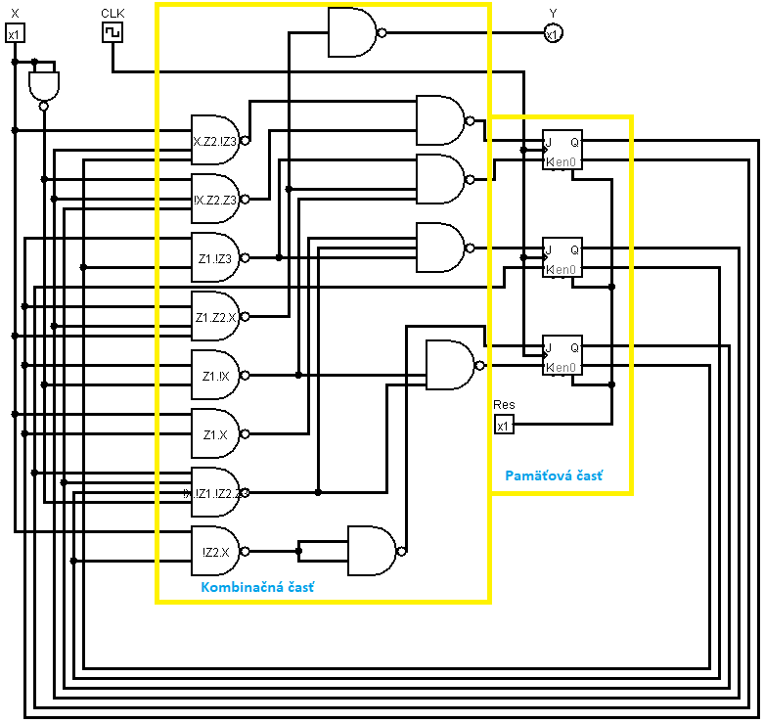

**Zhodnotenie:**

Mojím zadaním bolo zostrojiť sekvenčný logický obvod s postupnosťou 101101. Ako prvé som si vytvoril prechodový graf a nasledne prechodovú tabuľku pre automat typu Moore, kde som si zvolil v poslednom stave možnosť prekrývania. Stavy som si zakódoval náhodne. Zo zakódovanej tabuľky stavov som vytvoril Kaurgnaughove mapy budiacich funkcií, ktoré som následne prepísal do Kaurgnaughových máp budiacich funkcií pre JK preklápacie obvody (JK-PO) podľa ktorých som následne vypísal z máp MDNF. Boli zhodné s programom espresso. Po prepise na NAND s využitím Shefferovej operácie som svoje riešenie simuloval v programe logisim.